Graphs For Experiments

Circuit Analysis Lab
Zubair Bashir (2025-CE-100)

Experiment #1: Signal Generator and Oscilloscope

Resistor Values
R1 = 5.1 kΩ
R2 = 3.3 kΩ
Resistor | RMS Voltage (V) | P-P Voltage (V)
R1 | 1.09V | 3.04V
R2 | 0.69V | 1.96V

Oscilloscope Wave Graphs
Input Voltage Signal (5 Vpp, 100 Hz)
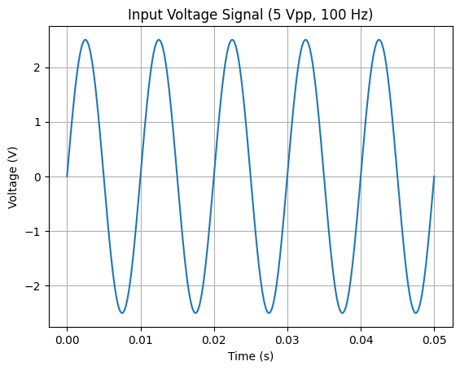
Voltage Across R1 (~3.04 Vpp)
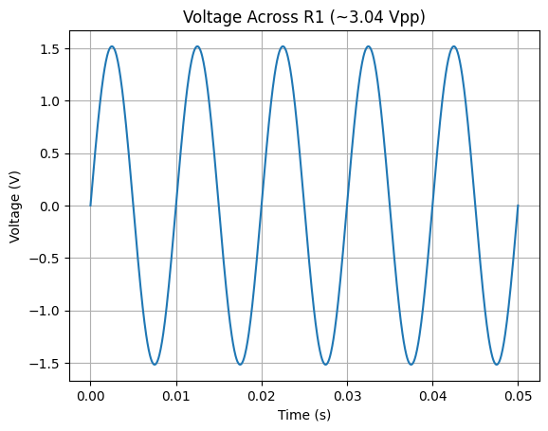
Voltage Across R2 (~1.96 Vpp)
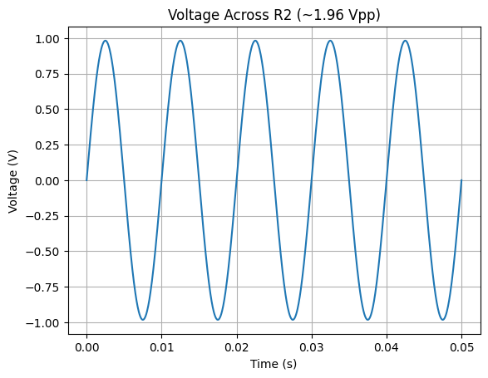
7V Sinusoidal Wave
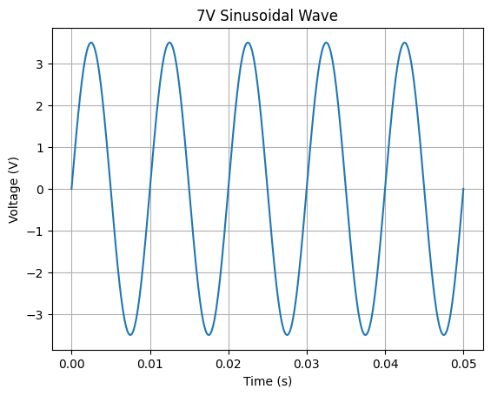

Experiment #2: Signal Generator and Oscilloscope

Resistor Values
R1 = 4.7 kΩ
R2 = 3.3 kΩ
R3 = 5.1 kΩ

Calculated Voltage Values
Resistor | RMS Voltage (V) | P-P Voltage (V)
R1 | 0.888 | 2.511
R2 | 0.623 | 1.763
R3 | 0.964 | 2.725
R1+R2 | 1.511 | 4.275
R2+R3 | 1.587 | 4.489

Graphs
Input Voltage Signal (7V)
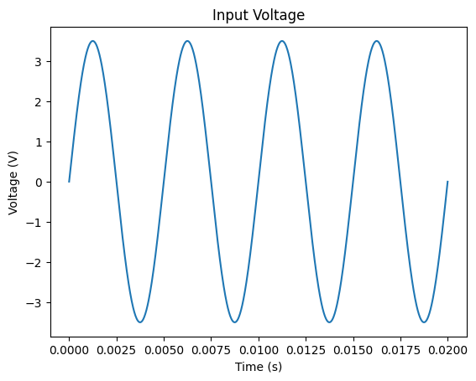
Voltage Signal across R1
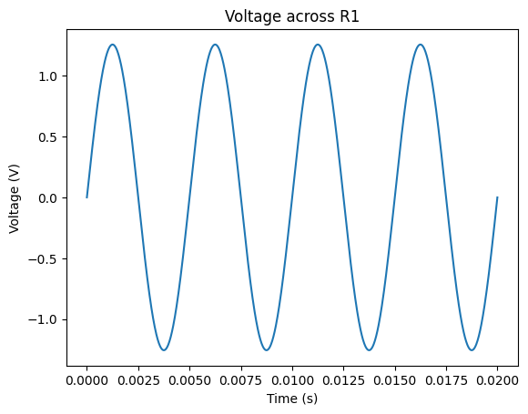
Voltage Signal across R2
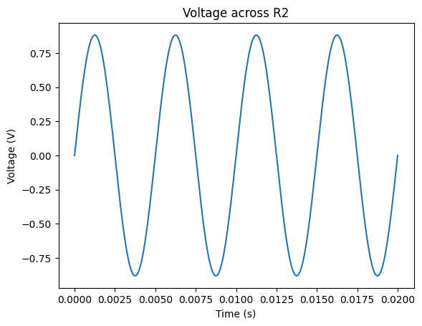
Voltage Signal across R3
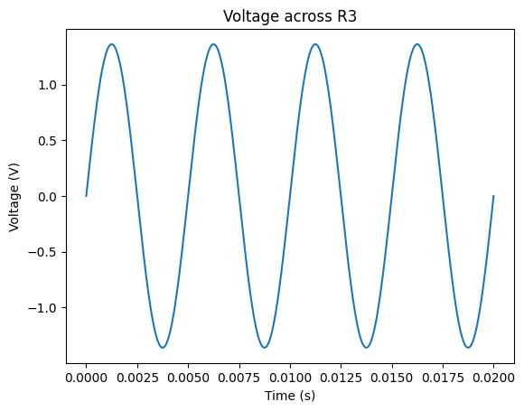
Voltage Signal across R1+R2
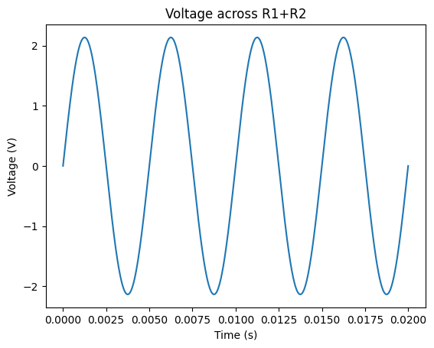
Voltage Signal across R2+R3
